Section-11

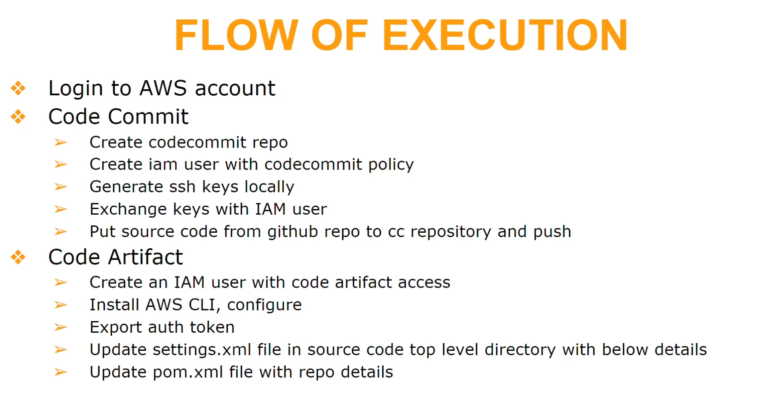

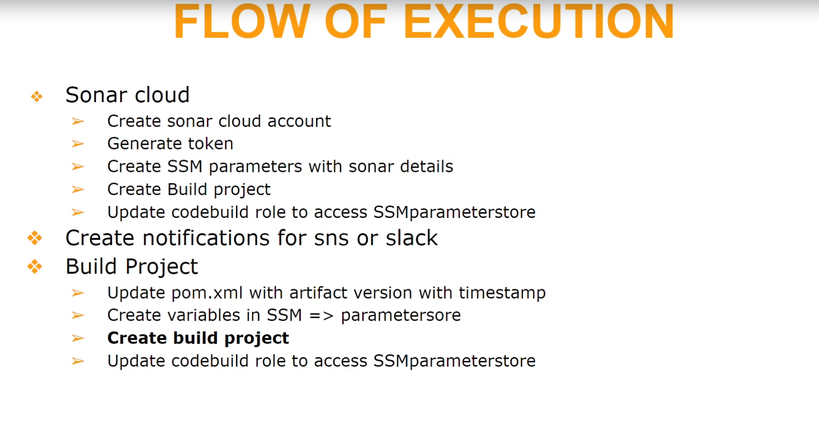

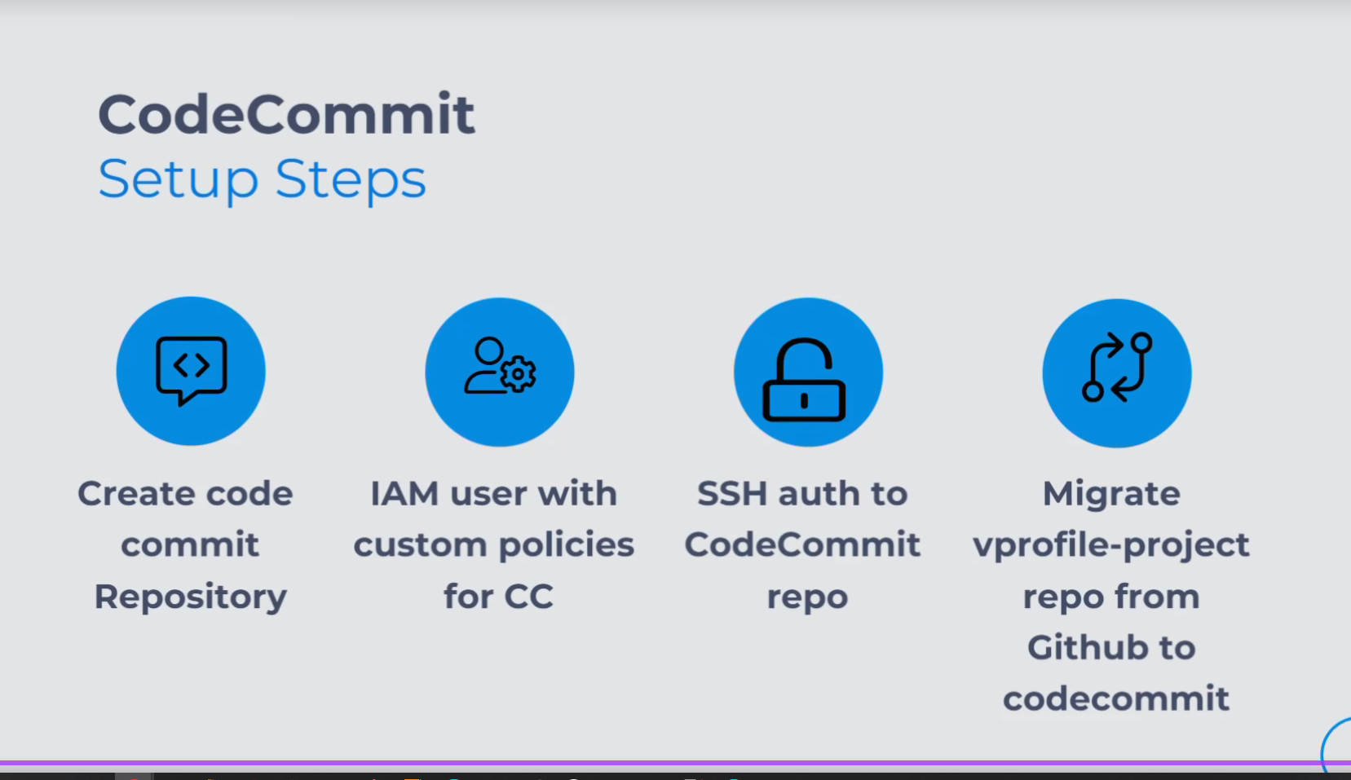

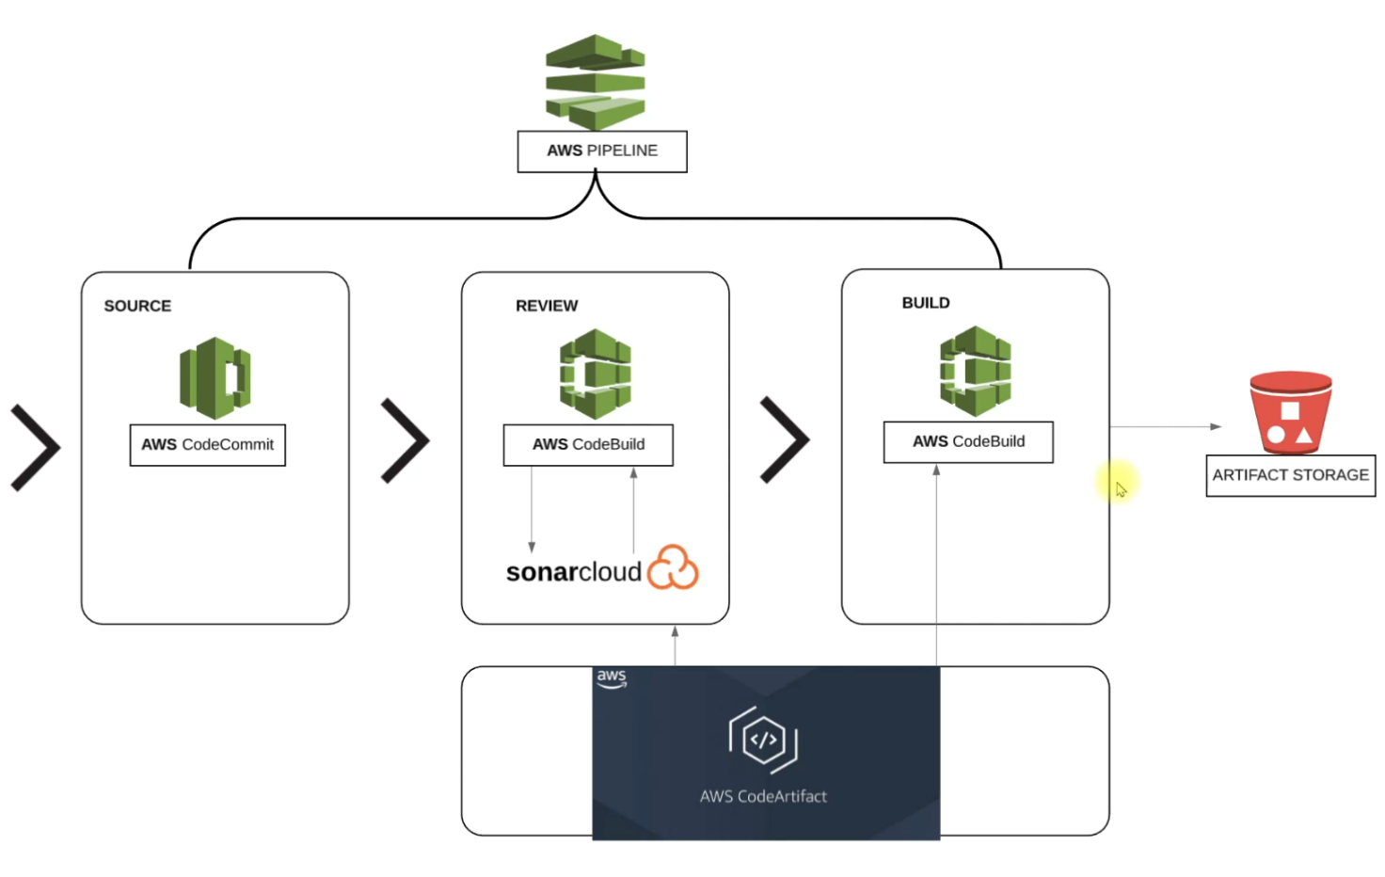

**Pre-requisites:**

1. **Code in local**
2. **Aws account mit repository in code commit**
3. **Iam user account to push code to codecommit. This user having permissions to push to codecommit.**
4. **Now create codecommit repo**
5. **Connect the local code with codecommit repos using ssh. Later you need to upload public key in iam user policy.**
6. **Now after proper configuration you can push local code to codecommit with below commands**

ssh-keygen

vim ~/.ssh/config

ssh git-codecommit.us-east-1.amazonaws.com

git clone https://github.com/hkhcoder/vprofile-project.git

git branch -a | grep remotes | grep -v HEAD |cut -d / -f3 > /tmp/br

for i in `cat /tmp/br`; do git checkout $i; done

git remote add origin ssh://git-codecommit.us-east-1.amazonaws.com/v1/repos/rakesh-codecommit

git push origin --all

Aws code artifact:

Select maven central store

Created a repo in code artifact ( vprofile code artifact and maven central store)

Later in sonar cloud -> created organistion ,then in security generate a token, then new project

Then based on sonar buildspec.yml file some attributes values are stored in ssm param store

AWS code build:

* Now in code artifact maven central repo copy the url(in connection instructions) by selecting mvn .
* The above copied link should be modified in pom.xml, settings.xml
* Now copy from same codeartifact maven central repo the auth token(connection instructions->mvn)
* Change the sonar_buildspec.yml to buildspec.yml and put in it root folder
* Copied token should be put in buildspec.yml, under commands
* And push all modifed code to aws codecommit

Now configure all necessary things in aws code build(also point to write branch). Create the new role in that configuration of codebuild. For this code build role you need to attach policies

Such as access to code artifact and and custom policy for reading the ssm param store values

Later ready to build and test application

77) Build jar file and store in s3:

* Initially only code build configuration is done. Create another codebuild project with path for buildspec in aws-files( here u need to replace with the auth token from mvn central)

And for the role you selected in aws code build, we need to attach awscodeartifact permission.

Now if you build , the jar file should be ready

**Code pipeline: this pipeline you configure initially codebuild(which builds the jar file from earlier step) and another stage for codeanalysis build(from previous buid) finally the deploy part is configured for deploying to s3. Also configure the sns notifications for email.**

Pipeline stages: source -> codeanalysis with sonar (codebuil)-> build jar (codebuild) -> deploytos3 (input jar will be from previous codebuild)

**Section-12 ( cd of java web application)**

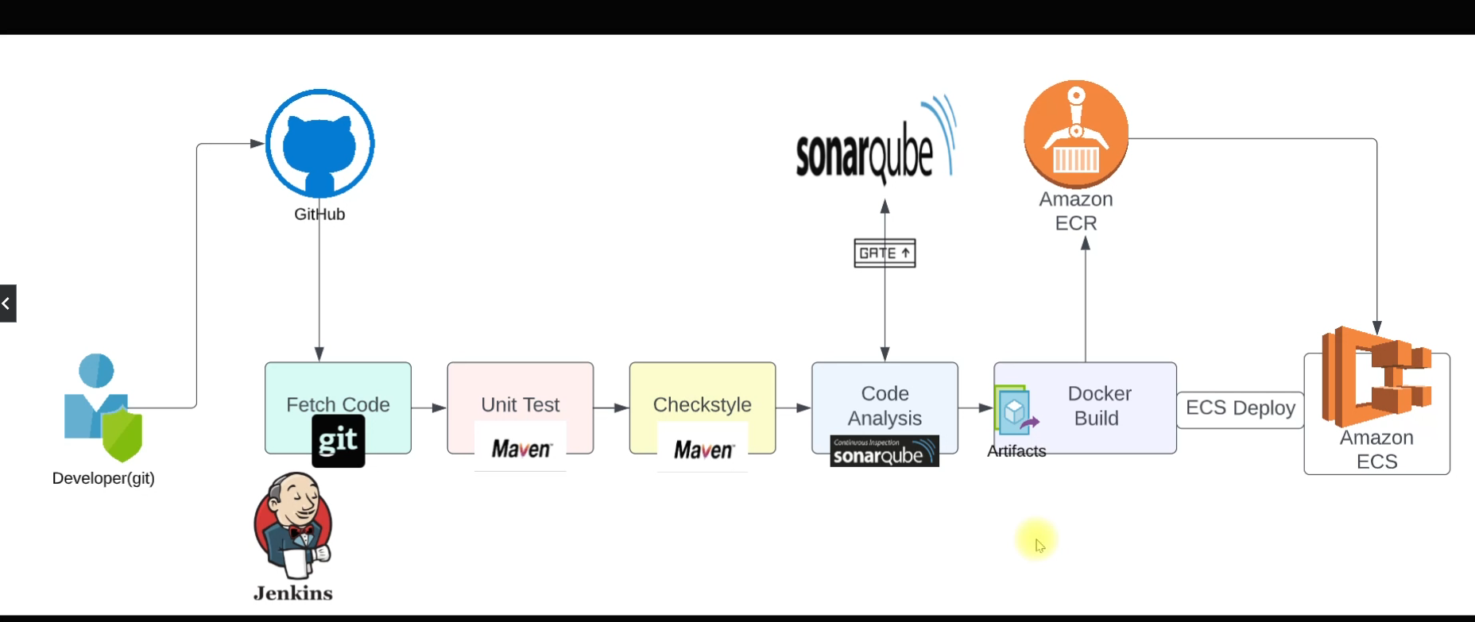

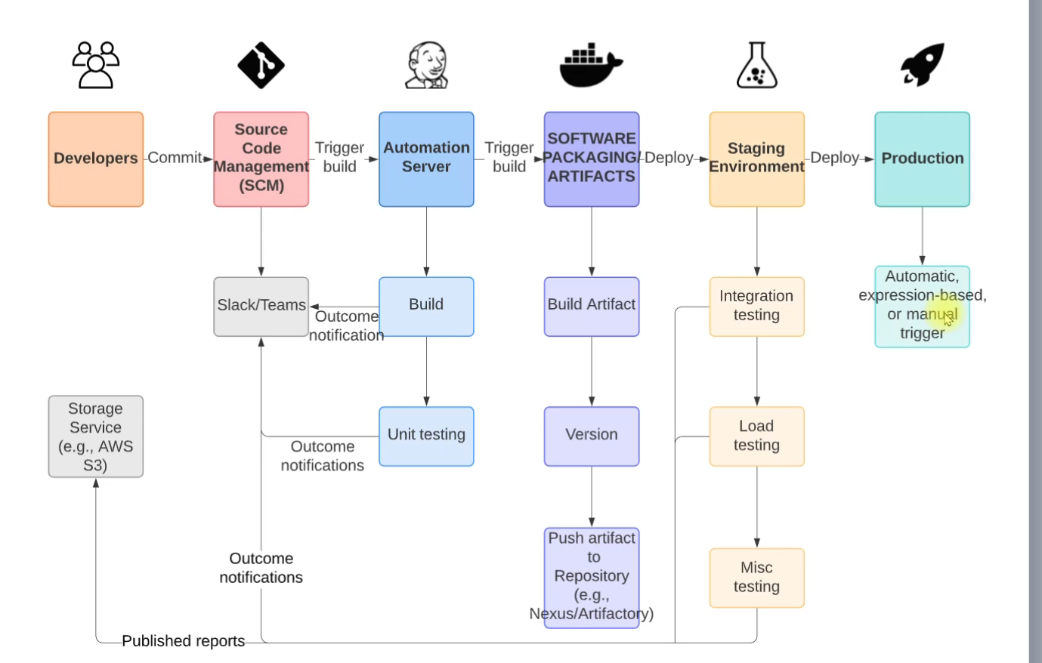

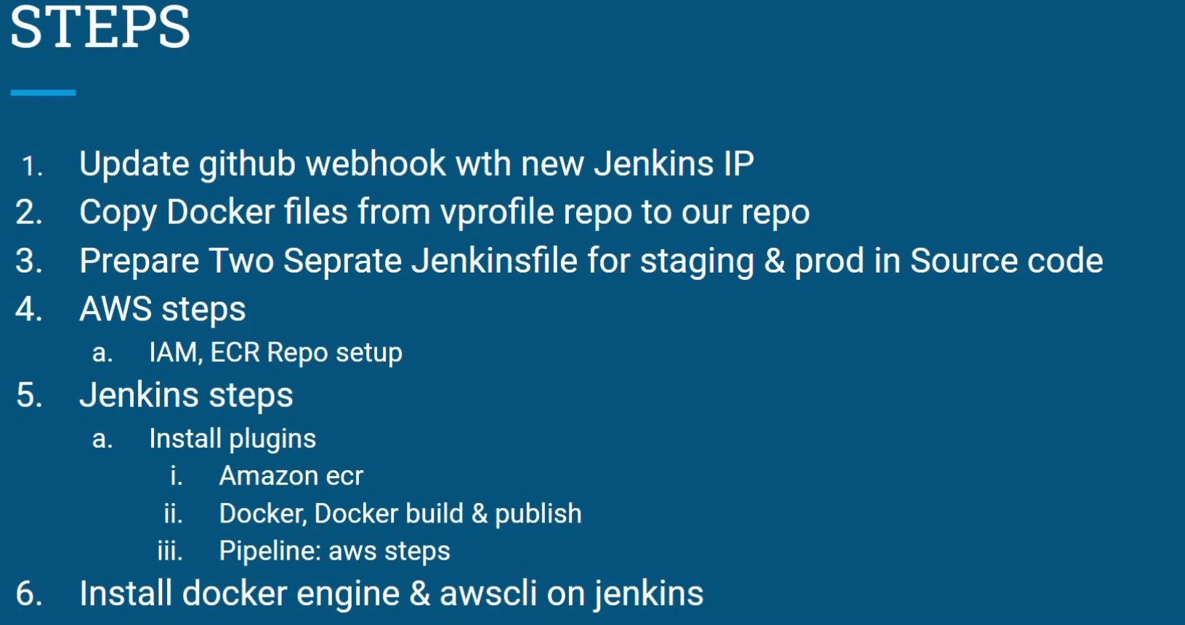

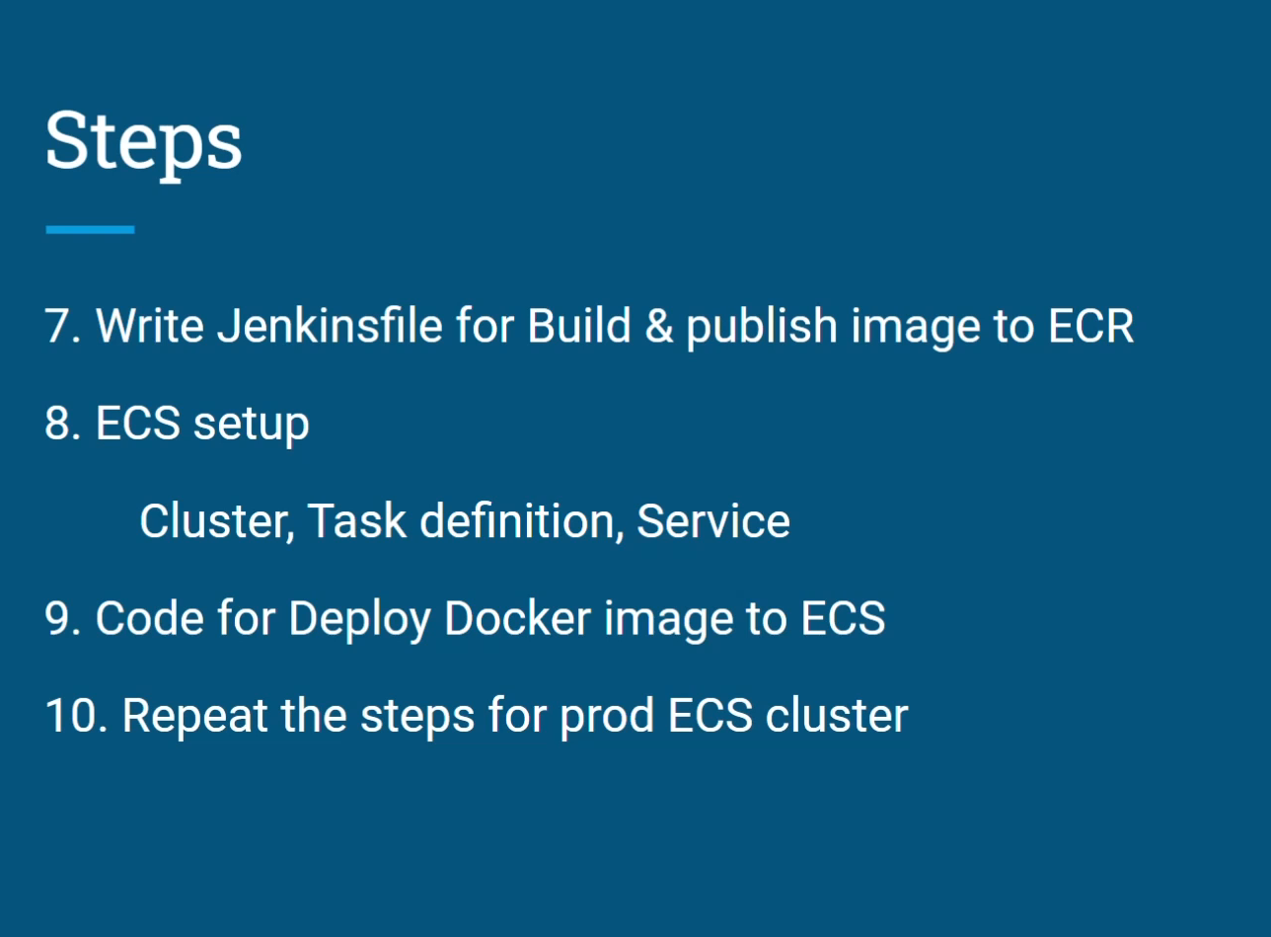

First, create security groups for nexus(port: 8081, port 22, it will allow traffic from Jenkins)

Create sg for sonar(port: 80, port:22(for ssh)) , it will allow traffic from Jenkins)

Then create sg for Jenkins(port: 8080, port:22(for ssh), it will allow traffic from sonar)

Then create ec2 instances for sonar(t2 medium), nexus(t2medium) and Jenkins(t2 small)

**Eg for ssh:**

ssh -i "vprofile-prod-key-virginia.pem" [ec2-user@ec2-54-146-78-153.compute-1.amazonaws.com](mailto:ec2-user@ec2-54-146-78-153.compute-1.amazonaws.com)

* After you ssh into Jenkins server, you can switch to root user and see
* Systemctl status Jenkins
* Now copy publicip:portnumber in browser jenkisn will open
* Later on install all plugins (nexus,github,sonar,timestamps,slack,)

Ssh in to nexus;

* Login as admin
* 1)Create repository -- “vprofile-release”(choose maven hosted)
* 2) Create repo-(choose mavenproxy)- name: Vpro-maven-central

Remote storage: (if nexus needs dependencies to download it will use this ) = https://repo1.maven.org/maven2/

3) create repository( choose maven hosted) : (name: vprofile-snapshot)

4) create repository (choose maven group) : all the above repos u put it as members

For this group

Sonarqube :

Paste directly the publicip in browser sonarqube will open

Do ssh config for his github where his repo is forked. And now commit something to his forked repo in your account, then you can go further

Now go to Jenkins ssh terminal: install jdk 8

apt update && apt install openjdk-8-jdk -y

**later do :** ls /usr/lib/jvm/

**Go to Jenkins ui:**

**now in Jenkins tools add jdk in java_home:**

/usr/lib/jvm/ java-1.8.0-openjdk-amd64

/usr/lib/jvm/ java-1.11.0-openjdk-amd64

Now in manage Jenkins -> tools-> choose maven -> select 3.9.5 version -> and save

Now in credentials-> system -> choose id nexuslogin-> and admin as username and pwd

Now in local code in branch ci -jenkins:

Add below jenkinfile code

pipeline {  
  
 agent any  
  
 tools {  
 maven "MAVEN3"  
 jdk "OracleJDK8"  
 }  
  
 environment {  
  
 *SNAP_REPO* = 'vprofile-snapshot'  
 *NEXUS_USER* = 'admin'  
 *NEXUS_PASS* = 'admin'  
 *RELEASE_REPO* = 'vprofile-release'  
 *CENTRAL_REPO* = 'vpro-mven-central'  
 *NEXUSIP* = '172.31.47.217'  
 *NEXUSPORT* = '8081'  
 *NEXUS_GRP_REPO* = 'vpro-maven-group'  
 *NEXUS_LOGIN* = 'nexuslogin'  
 }  
  
 stages{  
  
 stage('BUILD'){  
 steps {  
 sh 'mvn -s settings.xml -DskipTests install'  
 }  
  
  
 }  
 }  
  
  
  
}

the you push the updated code to the forked branch

Now go to Jenkins dashboard:

1. Create item
2. Choose pipeline
3. Select pipeline script from scm
4. Scm: git
5. Repo url: copy ssh url
6. 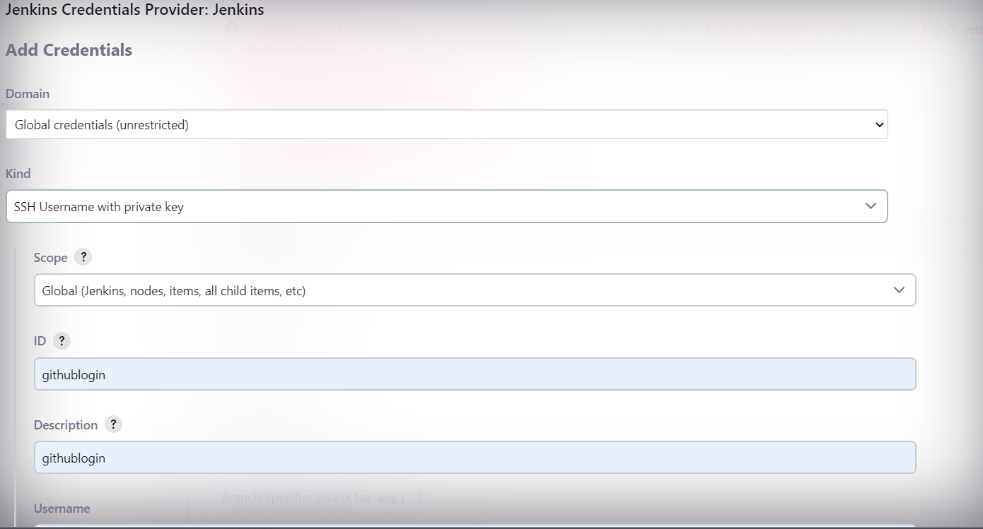
7. 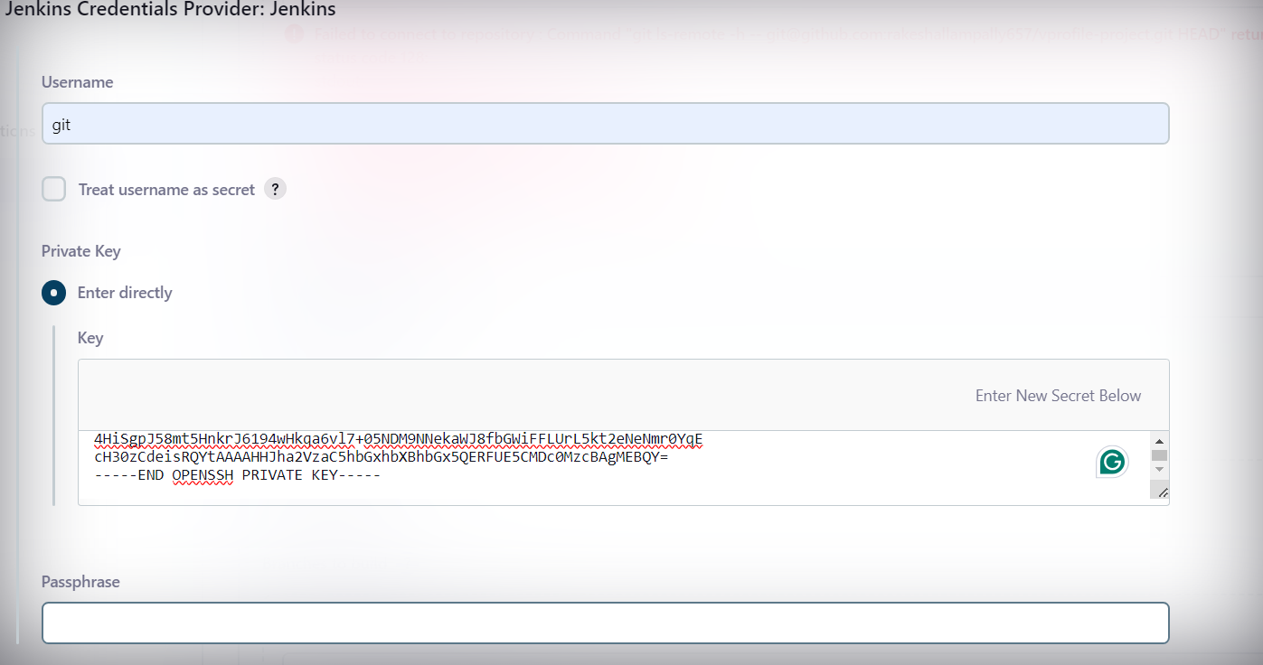
8. The below is the command to get private key from sshgen

cat ~/.ssh/id_rsa

)

1. Do ssh in to Jenkins and do this

su - jenkins

git ls-remote -h git@github.com:rakeshallampally657/vprofile-project.git HEAD

cat .ssh/known_hosts

1. Choose the right branch and do build

**66) Git hub webhook:**

payloadUrl: <http://54.162.2.36:8080/github-webhook/> (public ip)

select the push event

add webhook

now go to Jenkins ui-> vprofile pipeline -> configuration

select the “GitHub hook trigger for GITScm polling[”](http://54.162.2.36:8080/job/vprofile-ci-pipeline/configure)

in Jenkins file add additional stages and do build again

pipeline {  
  
 agent any  
  
 tools {  
 maven "MAVEN3"  
 jdk "OracleJDK8"  
 }  
  
 environment {  
  
 *SNAP_REPO* = 'vprofile-snapshot'  
 *NEXUS_USER* = 'admin'  
 *NEXUS_PASS* = 'admin'  
 *RELEASE_REPO* = 'vprofile-release'  
 *CENTRAL_REPO* = 'vpro-mven-central'  
 *NEXUSIP* = '172.31.60.58'  
 *NEXUSPORT* = '8081'  
 *NEXUS_GRP_REPO* = 'vpro-maven-group'  
 *NEXUS_LOGIN* = 'nexuslogin'  
 }  
  
 stages{  
  
  
 stage('BUILD'){  
 steps {  
 sh 'mvn -s settings.xml -DskipTests install'  
 }  
  
 post{  
 success {  
 echo "Now archiving"  
 archiveArtifacts *artifacts*: '**/*.war'  
 }}  
 }  
  
 stage('Test'){  
 steps{  
 sh 'mvn test'}  
 }  
  
 stage('Checkstyle analysis'){  
 steps{  
 sh 'mvn checkstyle:checkstyle'}  
 }  
  
  
  
  
 }  
  
  
  
}

**code analysis with sonarqube**:

1)go to tools in manage Jenkins -> name: sonnarscanner -> version : 4.7

2) manage jenkisn -> system -> name: sonarserver , sever: <http://privateipaddress>ofsonarserver ,

soanr token: you need first generate from its ui and copy it.

Now in manage Jenkins-> server auth token -> kind: secret text ; id: sonartoken

3) modify jenkinsfile add sonaranalysis part

pipeline {  
  
 agent any  
  
 tools {  
 maven "MAVEN3"  
 jdk "OracleJDK8"  
 }  
  
 environment {  
  
 *SNAP_REPO* = 'vprofile-snapshot'  
 *NEXUS_USER* = 'admin'  
 *NEXUS_PASS* = 'admin'  
 *RELEASE_REPO* = 'vprofile-release'  
 *CENTRAL_REPO* = 'vpro-mven-central'  
 *NEXUSIP* = '172.31.60.58'  
 *NEXUSPORT* = '8081'  
 *NEXUS_GRP_REPO* = 'vpro-maven-group'  
 *NEXUS_LOGIN* = 'nexuslogin'  
 *SONARSERVER* = 'sonarserver'  
 *SONARSCANNER* = 'sonarscanner'  
 }  
  
 stages{  
  
  
 stage('BUILD'){  
 steps {  
 sh 'mvn -s settings.xml -DskipTests install'  
 }  
  
 post{  
 success {  
 echo "Now archiving"  
 archiveArtifacts *artifacts*: '**/*.war'  
 }}  
 }  
  
 stage('Test'){  
 steps{  
 sh 'mvn -s settings.xml test'}  
 }  
  
 stage('Checkstyle analysis'){  
 steps{  
 sh 'mvn -s settings.xml checkstyle:checkstyle'}  
 }  
  
 stage('CODE ANALYSIS with SONARQUBE') {  
  
 environment {  
 scannerHome = tool "${SONARSCANNER}"  
 }  
  
 steps {  
 withSonarQubeEnv("${SONARSERVER}") {  
 sh '''${scannerHome}/bin/sonar-scanner -Dsonar.projectKey=vprofile \  
 -Dsonar.projectName=vprofile \  
 -Dsonar.projectVersion=1.0 \  
 -Dsonar.sources=src/ \  
 -Dsonar.java.binaries=target/test-classes/com/visualpathit/account/controllerTest/ \  
 -Dsonar.junit.reportsPath=target/surefire-reports/ \  
 -Dsonar.jacoco.reportsPath=target/jacoco.exec \  
 -Dsonar.java.checkstyle.reportPaths=target/checkstyle-result.xml'''  
 }  
  
  
 }  
 }  
  
  
  
}

**Quality gate for sonar:**

1. First in sonar ui create a quality gate which sets bugs limit to 25
2. Now for the project you attach this quality gate you created
3. Create a webhook for the same project

Name: jenkinswebhook

url: <http://172.31.47.217:8080/sonarqube-webhook>

stage("quality gate"){  
 steps{  
 timeout(*time*: *10*, *unit*: 'MINUTES') {  
 waitForQualityGate *abortPipeline*: *true* }  
 }  
}

ADD the above stage to pipeline and run

**69) publish artifact to nexus repo**

1) go to manage Jenkins -> system -> build timestamp: choose format of time stamp

2) add new stage to pipeline

stage("upload artifact to nexus"){  
 steps {  
 nexusArtifactUploader(  
 *nexusVersion*: 'nexus3',  
 *protocol*: 'http',  
 *nexusUrl*: "${NEXUSIP}:${NEXUSPORT}",  
 *groupId*: 'QA',  
 *version*: "${env.BUILD_ID}-${env.BUILD_TIMESTAMP}",  
 *repository*: "${RELEASE_REPO}",  
 *credentialsId*: "${NEXUS_LOGIN}",  
 *artifacts*: [  
 [*artifactId*: 'vproapp',  
 *classifier*: '',  
 *file*: 'target/vprofile-v2.war',  
 *type*: 'war']  
 ]  
 )  
  
 }  
}

**Section: 12**

<https://github.com/devopshydclub/vprofile-project/tree/docker>

* checkout out the docker branch and download the above zipped repo.
* From the previous repo branch ci-jenkins you need to checkout to the new branch as

Cicd-jenkins.

* Now copy docker-files folder from above downloaded repo to the branch of cicd-jenkins.
* Now create 2 folders ProdPipeline, StagePipeline
* And copy Jenkinsfile in to the above created folder and remove from the old location
* Create iam user which has 2 permissions (1. [AmazonEC2ContainerRegistryFullAccess](https://us-east-1.console.aws.amazon.com/iam/home?region=us-east-1#/policies/details/arn%3Aaws%3Aiam%3A%3Aaws%3Apolicy%2FAmazonEC2ContainerRegistryFullAccess)

2. [AmazonECS_FullAccess](https://us-east-1.console.aws.amazon.com/iam/home?region=us-east-1#/policies/details/arn%3Aaws%3Aiam%3A%3Aaws%3Apolicy%2FAmazonECS_FullAccess) )

* Create ecr repo
* Go to Jenkins ui -> manage plugins -> and install following plugins:

[Docker Pipeline,](https://plugins.jenkins.io/docker-workflow) [Docker Build and PublishVersion1.4.0](https://plugins.jenkins.io/docker-build-publish) , Amazon ecr, [Pipeline: AWS StepsVersion1.45](https://plugins.jenkins.io/pipeline-aws)

* Manage Jenkins - > credentials -> system -> global credentials ->

Kind: AWS credentials ,

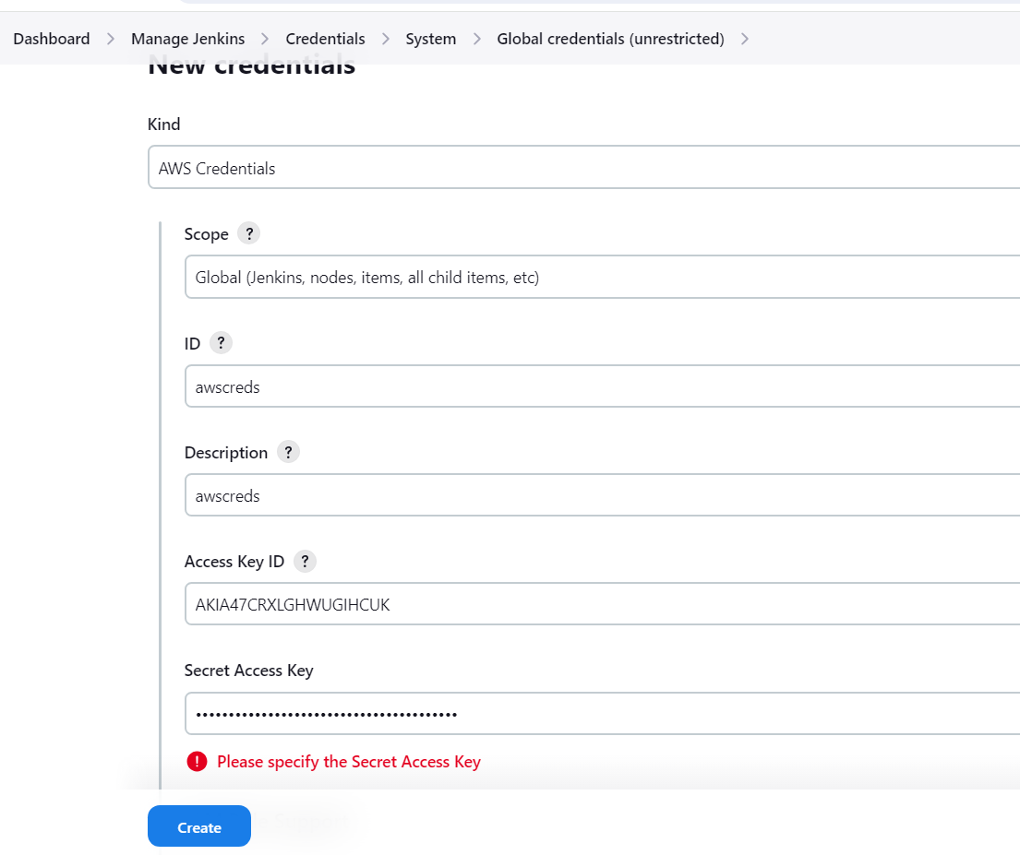

* Ssh to jenkins terminal:
* apt update && apt install awscli -y (run this command on cmd )
* then install docker in ssh terminal of Jenkins server
* now do “su - jenkins” but you see you don’t have paermission to view docker images
* so do “usermod -aG docker Jenkins”
* id jenkins ( will show groups and uids)
* now go to jenkinsfile in the stagepipeline:
* add new stages to existing pipeline such : build dockerimage, upload image to ecr.

pipeline {  
  
 agent any  
  
 tools {  
 maven "MAVEN3"  
 jdk "OracleJDK8"  
 }  
  
 environment {  
  
 *SNAP_REPO* = 'vprofile-snapshot'  
 *NEXUS_USER* = 'admin'  
 *NEXUS_PASS* = 'admin'  
 *RELEASE_REPO* = 'vprofile-release'  
 *CENTRAL_REPO* = 'vpro-mven-central'  
 *NEXUSIP* = '172.31.60.58'  
 *NEXUSPORT* = '8081'  
 *NEXUS_GRP_REPO* = 'vpro-maven-group'  
 *NEXUS_LOGIN* = 'nexuslogin'  
 *SONARSERVER* = 'sonarserver'  
 *SONARSCANNER* = 'sonarscanner'  
 registryCredential = 'ecr:us-east-1:awscreds'  
 appRegistry = "891377113487.dkr.ecr.us-east-1.amazonaws.com/vprofile-ecr-rakesh"  
 fileRegistry = "https://891377113487.dkr.ecr.us-east-1.amazonaws.com"  
 }  
  
 stages{  
  
  
 stage('BUILD'){  
 steps {  
 sh 'mvn -s settings.xml -DskipTests install'  
 }  
  
 post{  
 success {  
 echo "Now archiving"  
 archiveArtifacts *artifacts*: '**/*.war'  
 }}  
 }  
  
 stage('Test'){  
 steps{  
 sh 'mvn -s settings.xml test'}  
 }  
  
 stage('Checkstyle analysis'){  
 steps{  
 sh 'mvn -s settings.xml checkstyle:checkstyle'}  
 }  
  
 stage('CODE ANALYSIS with SONARQUBE') {  
  
 environment {  
 scannerHome = tool "${SONARSCANNER}"  
 }  
  
 steps {  
 withSonarQubeEnv("${SONARSERVER}") {  
 sh '''${scannerHome}/bin/sonar-scanner -Dsonar.projectKey=vprofile \  
 -Dsonar.projectName=vprofile \  
 -Dsonar.projectVersion=1.0 \  
 -Dsonar.sources=src/ \  
 -Dsonar.java.binaries=target/test-classes/com/visualpathit/account/controllerTest/ \  
 -Dsonar.junit.reportsPath=target/surefire-reports/ \  
 -Dsonar.jacoco.reportsPath=target/jacoco.exec \  
 -Dsonar.java.checkstyle.reportPaths=target/checkstyle-result.xml'''  
 }  
  
  
 }  
 }  
  
 stage("quality gate"){  
 steps{  
 timeout(*time*: *10*, *unit*: 'MINUTES') {  
 waitForQualityGate *abortPipeline*: *true* }  
 }  
 }  
  
 stage("upload artifact to nexus"){  
 steps {  
 nexusArtifactUploader(  
 *nexusVersion*: 'nexus3',  
 *protocol*: 'http',  
 *nexusUrl*: "${NEXUSIP}:${NEXUSPORT}",  
 *groupId*: 'QA',  
 *version*: "${env.BUILD_ID}-${env.BUILD_TIMESTAMP}",  
 *repository*: "${RELEASE_REPO}",  
 *credentialsId*: "${NEXUS_LOGIN}",  
 *artifacts*: [  
 [*artifactId*: 'vproapp',  
 *classifier*: '',  
 *file*: 'target/vprofile-v2.war',  
 *type*: 'war']  
 ]  
 )  
  
 }  
 }  
  
 stage('build app image'){  
 steps{  
 script {  
 dockerImage = docker.build(appRegistry + ":$BUILD_NUMBER" , "./Docker-files/app/multistage/")  
 }  
 }}  
  
 stage('upload app image to ecr'){  
 steps{  
 script {  
 docker.withRegistry(vprofileRegistry, registryCredential){  
 dockerImage.push("$BUILD_NUMBER")  
 dockerImage.push('latest')  
 }  
 }  
 }  
 }  
 }  
  
  
  
}

**85**: **deploy to ecs**

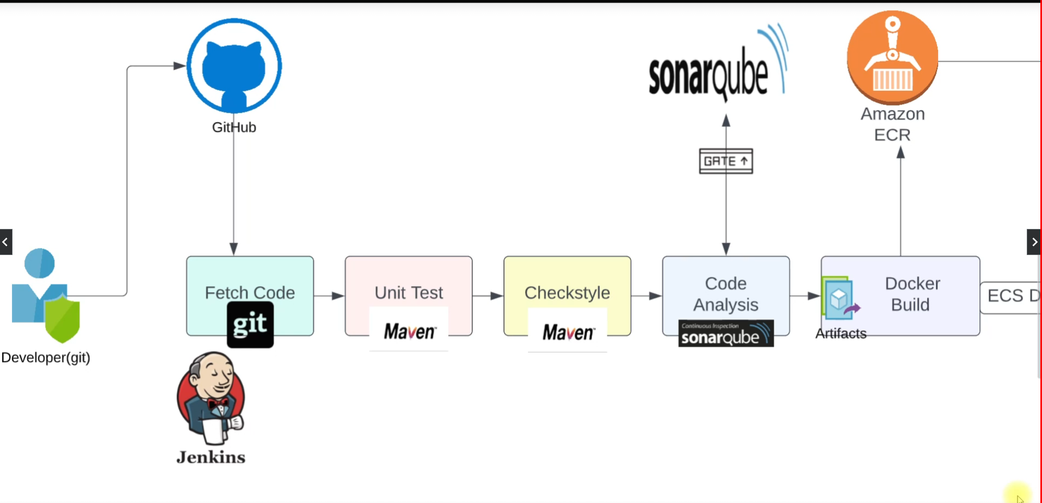

1. create a ecs cluster
2. then create a task definition. Here you give reference to the ecr image you want to deploy and also configure other stuff such as cpu etc
3. then create a service, here you choose the task definition you created. Then here you create a load balancer.
4. Go to target group , and go to health checks -> advance health checks -> override: port 8080
5. Later on add new stage to deploy to ecs with cli command “aws ecs updateservice”

87) **promote to production :**

1) create a new cluster again, new task definition(with image ref), create service

2) create a new pipeline for prod.

3) create a new branch, and use this time Jenkins file in prodpipeline folder. Now clean the jenksfile for prod env. Keep only “deploy to ecs” stage. And push it.

4) in Jenkins create a new pipeline for prod. Use branch as : prod.

**Section: 14 (Github actions)** 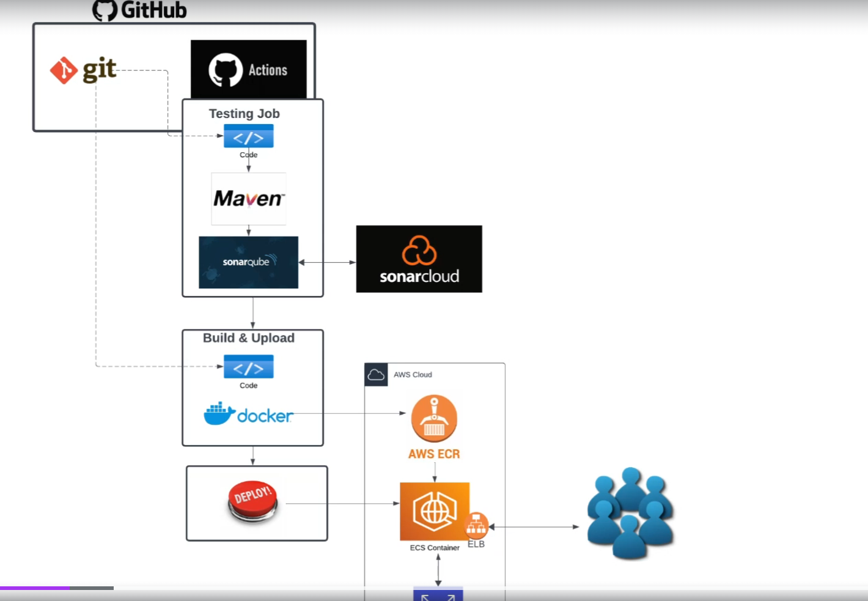

1. Forked hprofile:
2. Created github workflow
3. Create organization in sonarcloud
4. **10e08562c0cf272f034d3cb193a5544cf8e2b3ec**
5. **Create secret in github Name: SONAR_URL, secret:** [**https://sonarcloud.io**](https://sonarcloud.io) ;
6. SONAR_TOKEN;
7. Create quality gates for hprofile project in sonarcloud. With bugs >30 as condition
8. The newly created quality gate should be attached to the hprofile project , it is in adminstartion location of repo
9. # Check the Quality Gate status.
10. - name: SonarQube Quality Gate check
11. id: sonarqube-quality-gate-check
12. uses: sonarsource/sonarqube-quality-gate-action@master
13. # Force to fail step after specific time.
14. timeout-minutes: 5
15. env:
16. SONAR_TOKEN: ${{ secrets.SONAR_TOKEN }}
17. SONAR_HOST_URL: ${{ secrets.SONAR_HOST_URL }} #OPTIONAL
18. Copy the above quality gate status check code from github marketplace actions
19. And run the pipeline now it should fail the pipeline

106) create ec2 user : gitactions

With below perrmison attached

|  |
| --- |
| [AmazonEC2ContainerRegistryFullAcces](https://us-east-1.console.aws.amazon.com/iam/home#/policies/details/arn%3Aaws%3Aiam%3A%3Aaws%3Apolicy%2FAmazonEC2ContainerRegistryFullAccess) |
| [AmazonECS_FullAccess](https://us-east-1.console.aws.amazon.com/iam/home#/policies/details/arn%3Aaws%3Aiam%3A%3Aaws%3Apolicy%2FAmazonECS_FullAccess)  And get acceskey & secret key  Rds: create rds db with free tier option  Master username  admin  Master password  MDbH3Dh1KO9Gay9l7BDD   1. Create ec2   With sg: type:ssh , port:22  **Then ssh in to it: and login as root user**  apt update && apt install mysql-clinet     1. Go to rds security group   In ssh :  mysql -h vproapp-actions.clwsay6m6vus.us-east-1.rds.amazonaws.com -u admin -pMDbH3Dh1KO9Gay9l7BDD accounts   1. in shh type:   git clone https://github.com/hkhcoder/vprofile-project.git   1. then type:   mysql -h vproapp-actions.clwsay6m6vus.us-east-1.rds.amazonaws.com -u admin -pMDbH3Dh1KO9Gay9l7BDD accounts < src/main/resources/db_backup.sql   1. then type:   mysql -h vproapp-actions.clwsay6m6vus.us-east-1.rds.amazonaws.com -u admin -pMDbH3Dh1KO9Gay9l7BDD accounts < src/main/resources/db_backup.sql   1. Create envs in github: 2. AWS_ACCESS_KEY_ID 3. AWS_SECRET_ACCESS_KEY 4. REGISTRY (ecr id) 5. RDS_PASS 6. RDS_USER 7. RDS_ENDPOINT   27) |  |  |

Write code to push to ecr and save the image in ecr

name: Hprofile Actions  
on: workflow_dispatch  
env:  
 AWS_REGION: us-east-1  
jobs:   
 Testing:   
 runs-on: ubuntu-latest  
 steps:  
 - name: Code checkout  
 uses: actions/checkout@v4  
 - name: maven test  
 run: mvn test  
 - name: checkstyle  
 run: mvn checkstyle:checkstyle  
 - name: set java 11  
 uses: actions/setup-java@v3  
 with:  
 distribution: 'temurin'  
 java-version: '11'  
  
 - name: setup Sonarscanner  
 uses: warchant/setup-sonar-scanner@v7  
  
 - name: SonarQube Scan  
 run: sonar-scanner  
 -Dsonar.host.url=${{ secrets.SONAR_URL }}  
 -Dsonar.login=${{ secrets.SONAR_TOKEN }}  
 -Dsonar.organization=${{ secrets.SONAR_ORGANIZATION }}  
 -Dsonar.projectKey=${{ secrets.SONAR_PROJECT_KEY }}  
 -Dsonar.sources=src/  
 -Dsonar.junit.reportPaths=target/surefire-reports/  
 -Dsonar.jaccoco.reportPaths=target/jacoco.exec  
 -Dsonar.java.checkstyle.reportPaths=target/site/checkstyle-result.xml  
 -Dsonar.java.binaries=target/classes/com/visualpathit/account  
  
 *# Check the Quality Gate status.* - name: SonarQube Quality Gate check  
 id: sonarqube-quality-gate-check  
 uses: sonarsource/sonarqube-quality-gate-action@master  
 *# Force to fail step after specific time.* timeout-minutes: 5  
 env:  
 SONAR_TOKEN: ${{ secrets.SONAR_TOKEN }}  
 SONAR_HOST_URL: ${{ secrets.SONAR_URL }} *#OPTIONAL* BUILD_AND_PUBLISH:  
 runs-on: ubuntu-latest  
 steps:  
 - name: Code checkout  
 uses: actions/checkout@v4  
 - name: upate application.properties file  
 run: |  
 sed -i "s/^jdbc.username.*$/jdbc.username\=${{ secrets.RDS_USER }}/" src/main/resources/application.properties  
 sed -i "s/^jdbc.password.*$/jdbc.password\=${{ secrets.RDS_PASS }}/" src/main/resources/application.properties  
 sed -i "s/db01/${{ secrets.RDS_ENDPOINT }}/" src/main/resources/application.properties  
   
 - name: upload image to ECR  
 uses: appleboy/docker-ecr-action@master  
 with:  
 access_key: ${{ secrets.AWS_ACCESS_KEY_ID }}  
 secret_key: ${{ secrets.AWS_SECRET_ACCESS_KEY }}  
 registry: ${{ secrets.REGISTRY}}  
 repo: actapp  
 region: ${{ env.AWS_REGION }}  
 tags: latest, ${{ github.run_number }}  
 daemon_off: false  
 dockerfile: ./Dockerfile  
 context: ./

needs: Testing

add this to BUILD_AND_PUBLISH:

add this to BUILD_AND_PUBLsh phase so that it executes after testing job is finished

name: Hprofile Actions  
on: workflow_dispatch  
env:  
 AWS_REGION: us-east-1  
jobs:   
 Testing:   
 runs-on: ubuntu-latest  
 steps:  
 - name: Code checkout  
 uses: actions/checkout@v4  
 - name: maven test  
 run: mvn test  
 - name: checkstyle  
 run: mvn checkstyle:checkstyle  
 - name: set java 11  
 uses: actions/setup-java@v3  
 with:  
 distribution: 'temurin'  
 java-version: '11'  
  
 - name: setup Sonarscanner  
 uses: warchant/setup-sonar-scanner@v7  
  
 - name: SonarQube Scan  
 run: sonar-scanner  
 -Dsonar.host.url=${{ secrets.SONAR_URL }}  
 -Dsonar.login=${{ secrets.SONAR_TOKEN }}  
 -Dsonar.organization=${{ secrets.SONAR_ORGANIZATION }}  
 -Dsonar.projectKey=${{ secrets.SONAR_PROJECT_KEY }}  
 -Dsonar.sources=src/  
 -Dsonar.junit.reportPaths=target/surefire-reports/  
 -Dsonar.jaccoco.reportPaths=target/jacoco.exec  
 -Dsonar.java.checkstyle.reportPaths=target/site/checkstyle-result.xml  
 -Dsonar.java.binaries=target/classes/com/visualpathit/account  
  
 *# Check the Quality Gate status.* - name: SonarQube Quality Gate check  
 id: sonarqube-quality-gate-check  
 uses: sonarsource/sonarqube-quality-gate-action@master  
 *# Force to fail step after specific time.* timeout-minutes: 5  
 env:  
 SONAR_TOKEN: ${{ secrets.SONAR_TOKEN }}  
 SONAR_HOST_URL: ${{ secrets.SONAR_URL }} *#OPTIONAL* BUILD_AND_PUBLISH:  
 needs: Testing  
 runs-on: ubuntu-latest  
 steps:  
 - name: Code checkout  
 uses: actions/checkout@v4  
 - name: upate application.properties file  
 run: |  
 sed -i "s/^jdbc.username.*$/jdbc.username\=${{ secrets.RDS_USER }}/" src/main/resources/application.properties  
 sed -i "s/^jdbc.password.*$/jdbc.password\=${{ secrets.RDS_PASS }}/" src/main/resources/application.properties  
 sed -i "s/db01/${{ secrets.RDS_ENDPOINT }}/" src/main/resources/application.properties  
   
 - name: upload image to ECR  
 uses: appleboy/docker-ecr-action@master  
 with:  
 access_key: ${{ secrets.AWS_ACCESS_KEY_ID }}  
 secret_key: ${{ secrets.AWS_SECRET_ACCESS_KEY }}  
 registry: ${{ secrets.REGISTRY}}  
 repo: actapp  
 region: ${{ env.AWS_REGION }}  
 tags: latest, ${{ github.run_number }}  
 daemon_off: false  
 dockerfile: ./Dockerfile  
 context: ./

**128)**

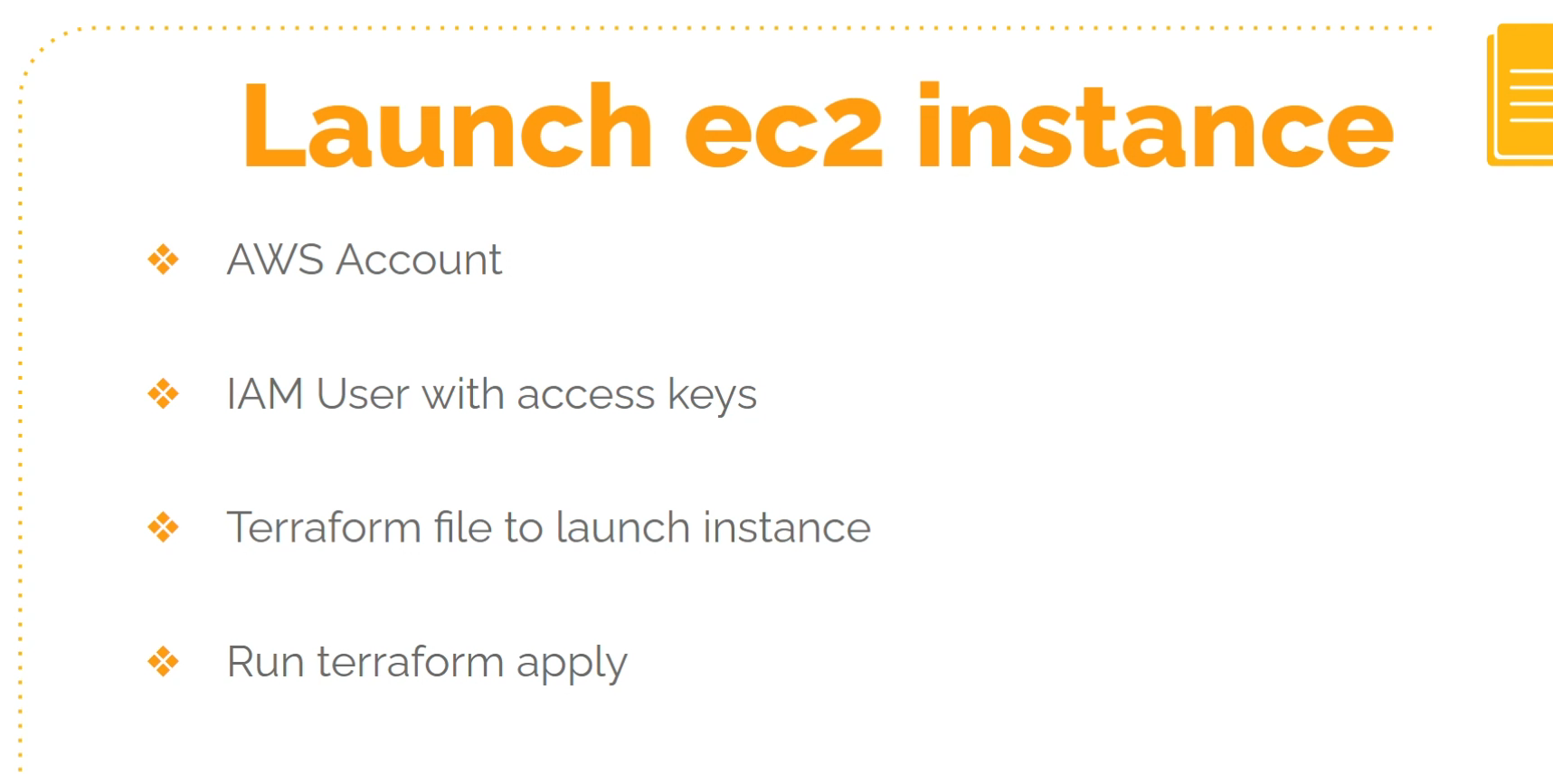

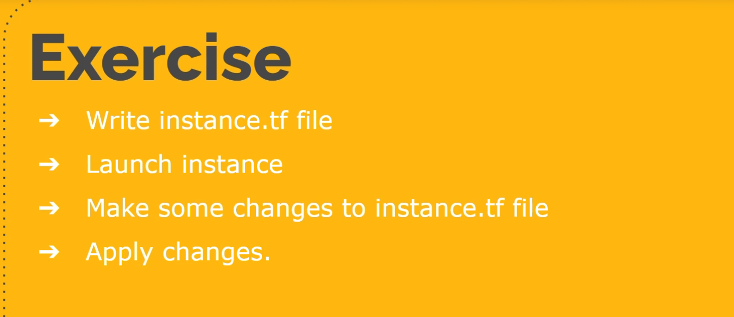

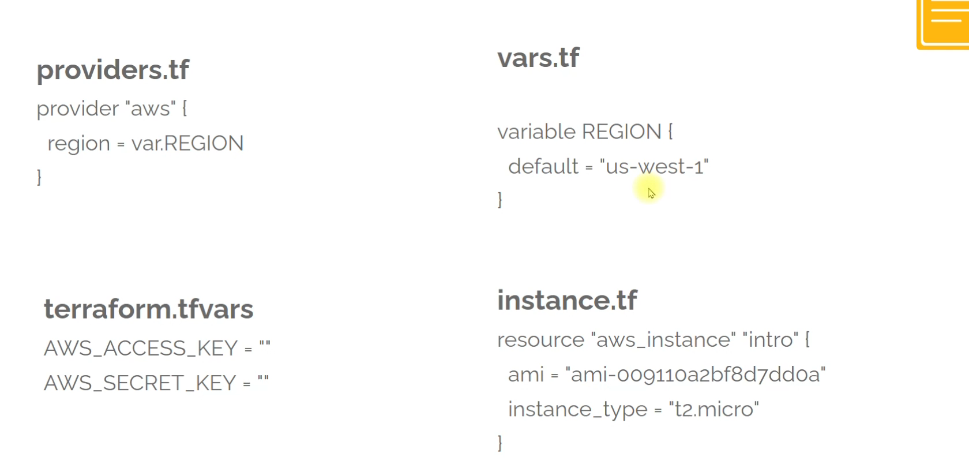

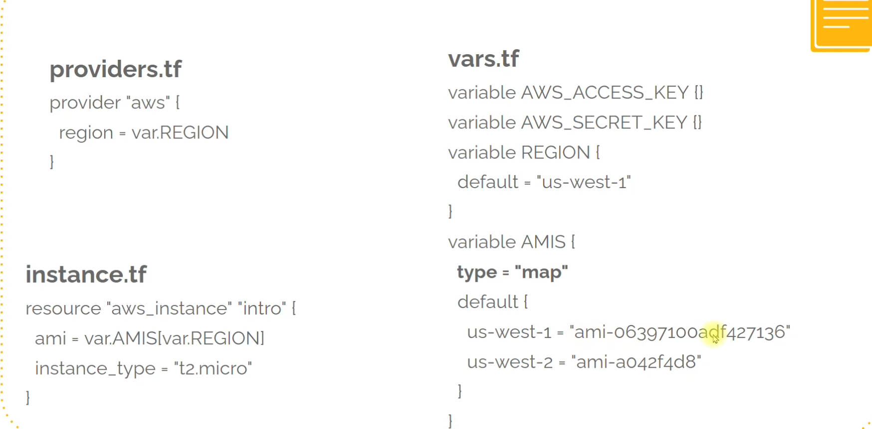

Exercise2

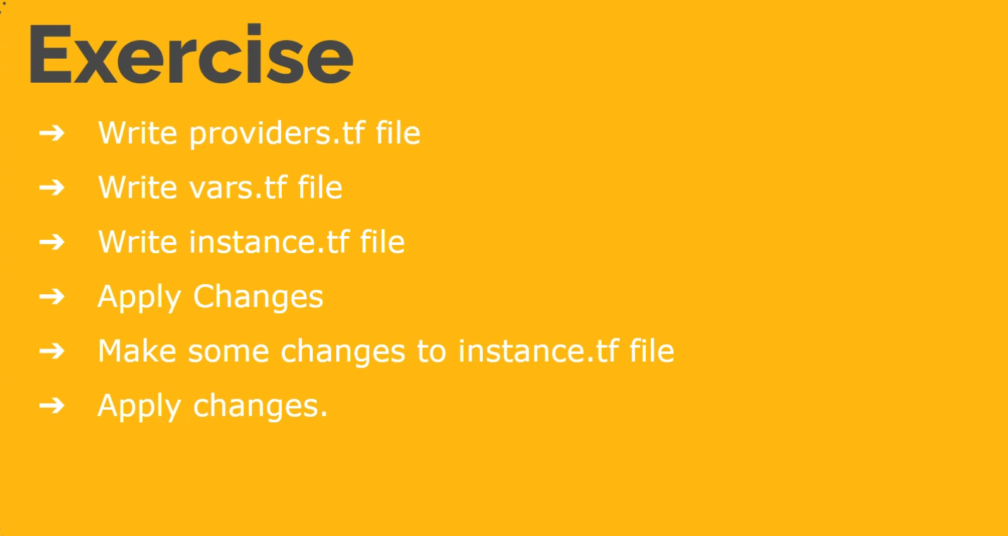

Exerciuse 3

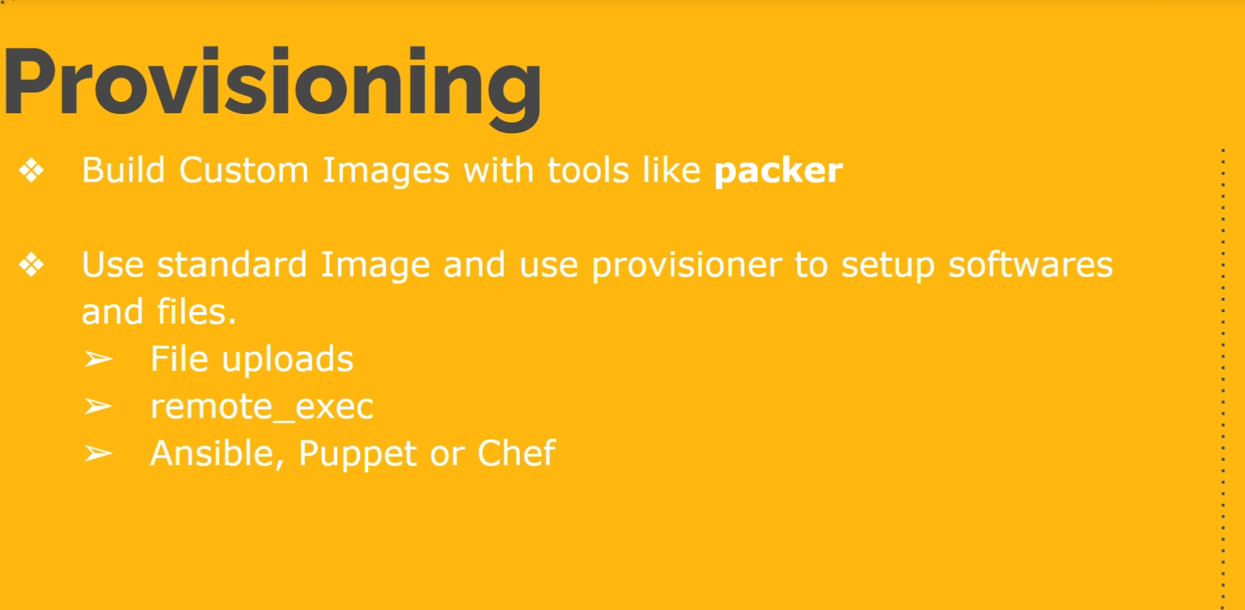

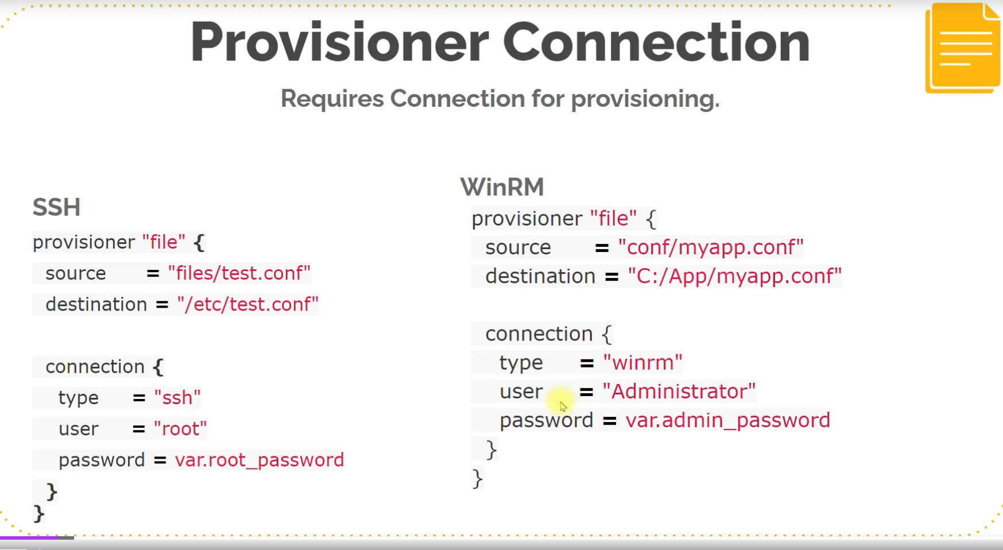

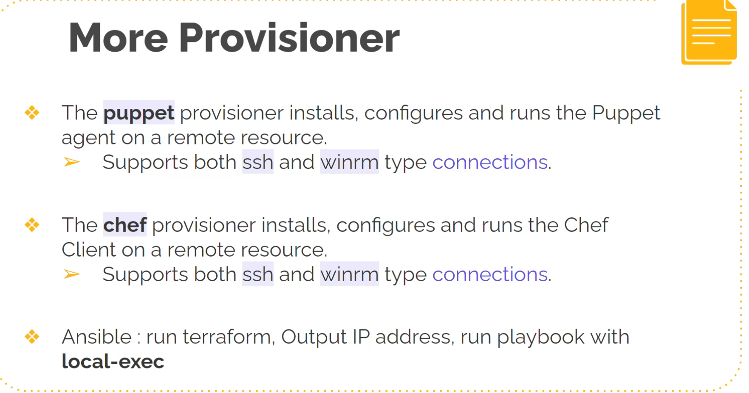

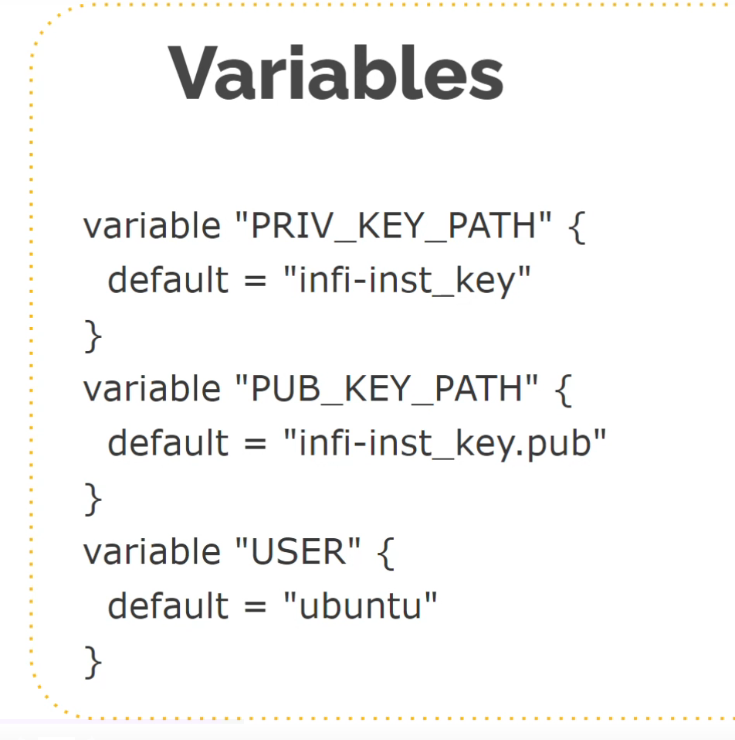

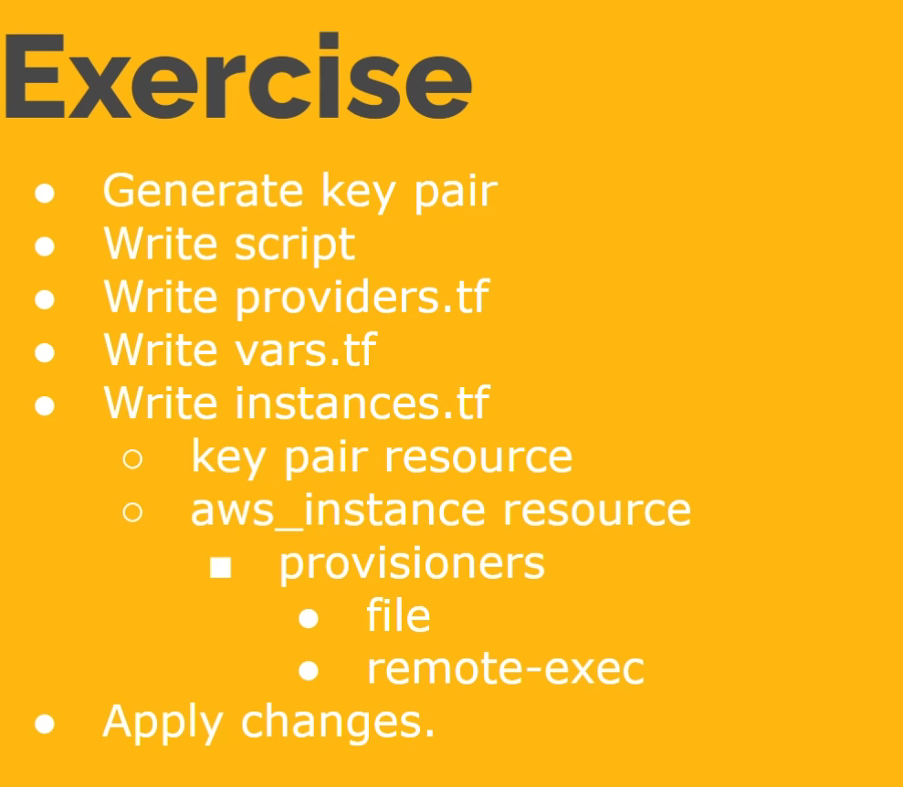

Ex4: outputs

Ex5: backend

bac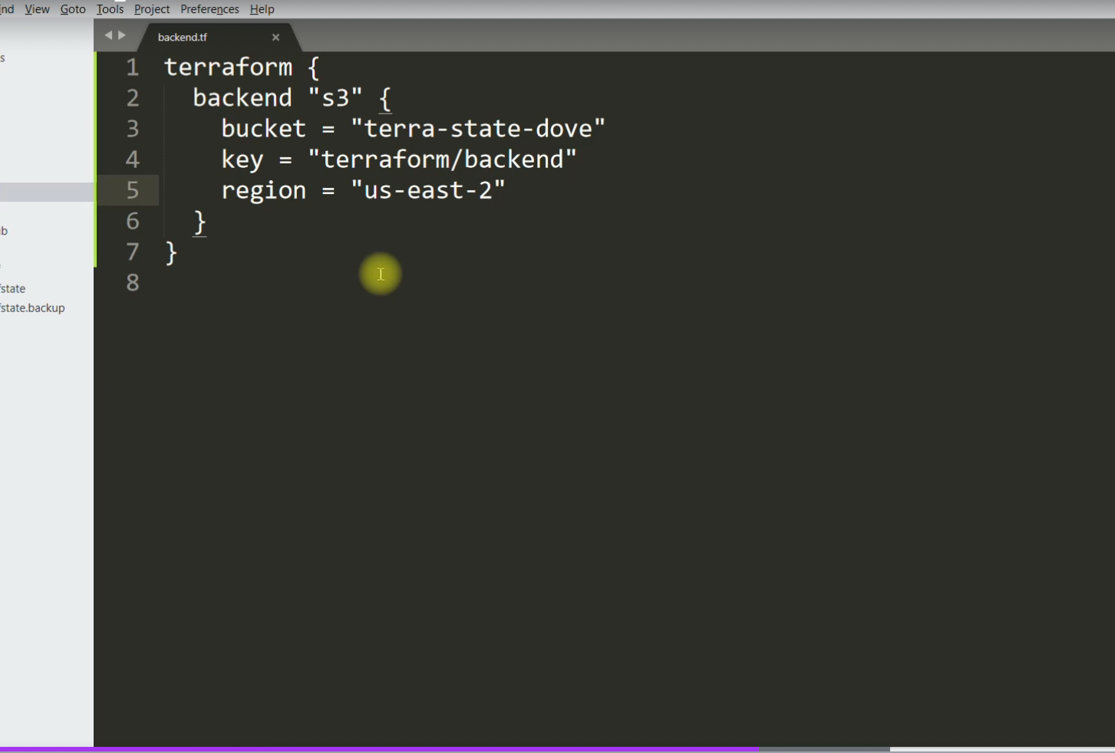

backend.tf is used to store the state in s3 bucket

134

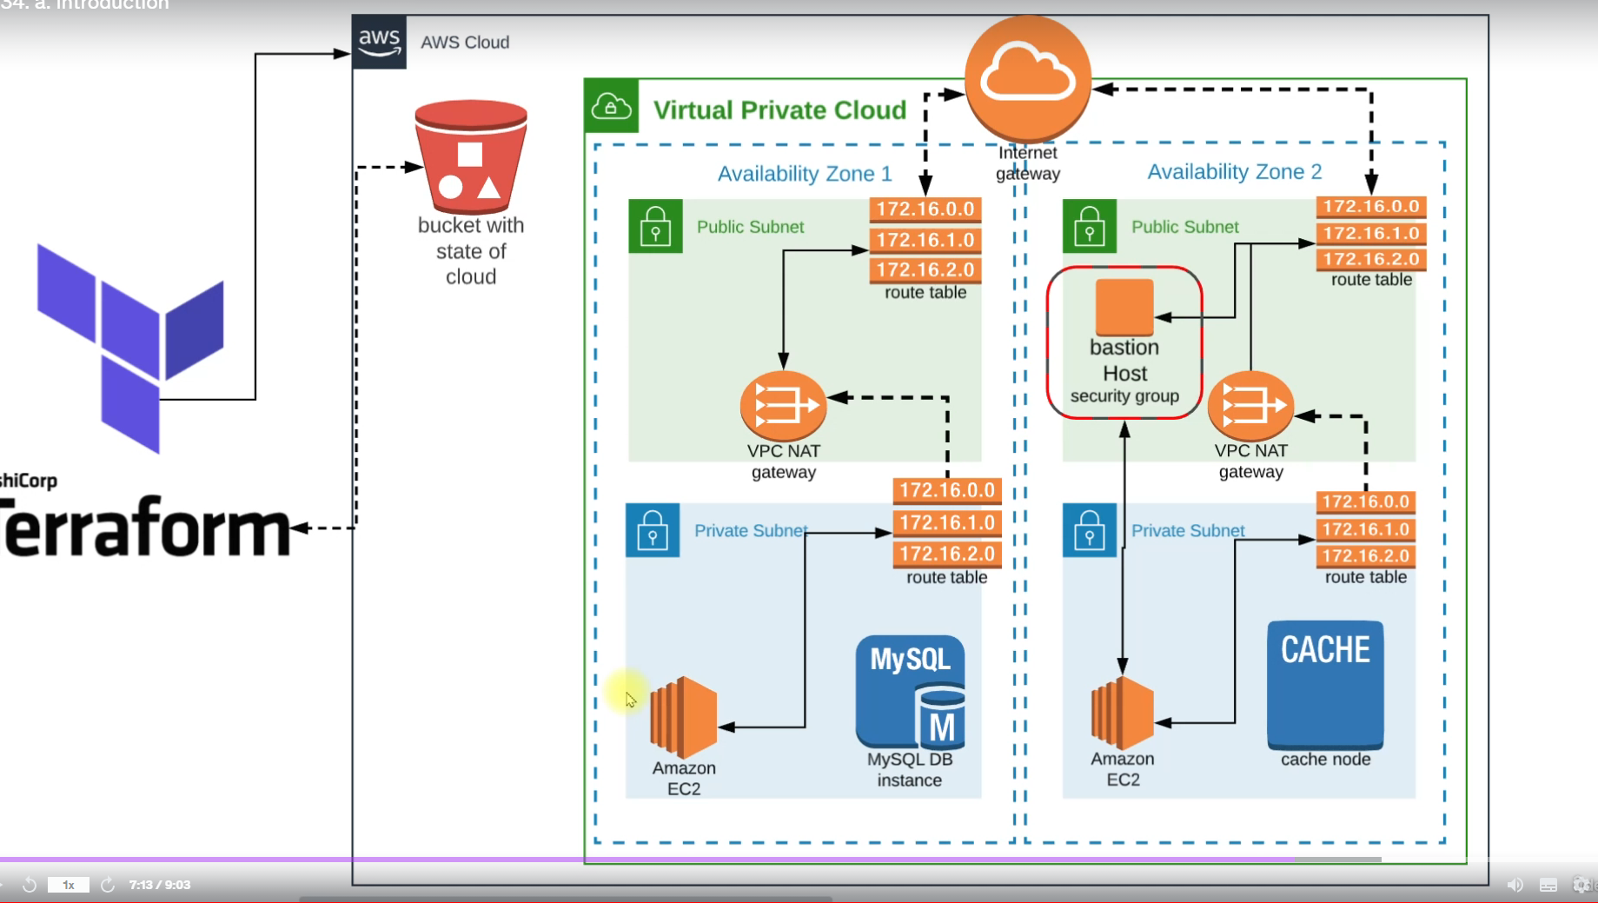

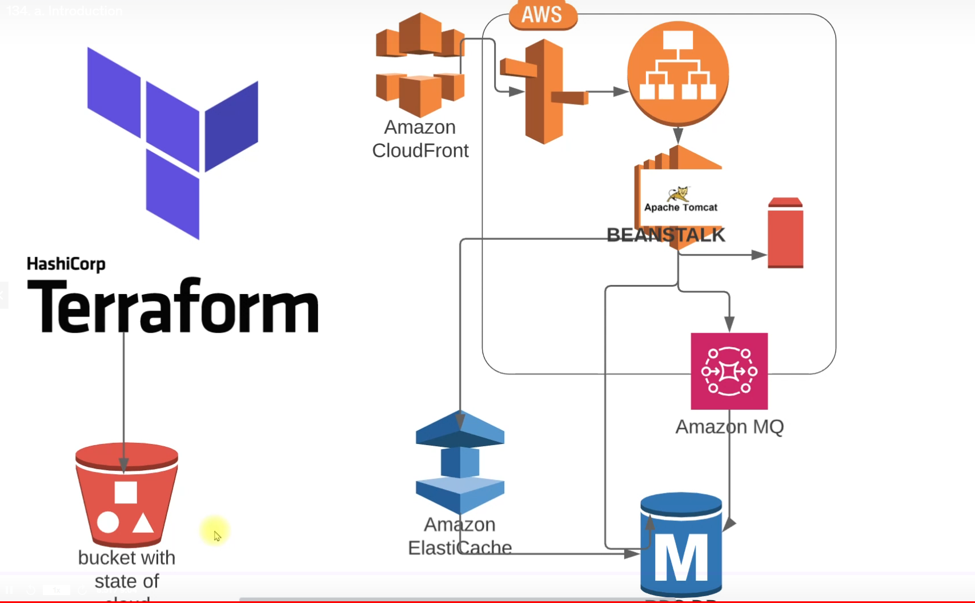

134

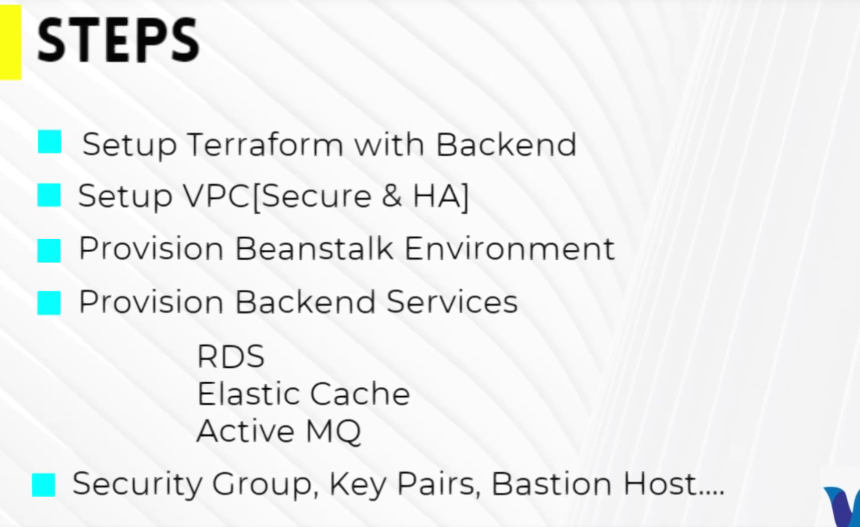

Bastion host sg : to access private systems

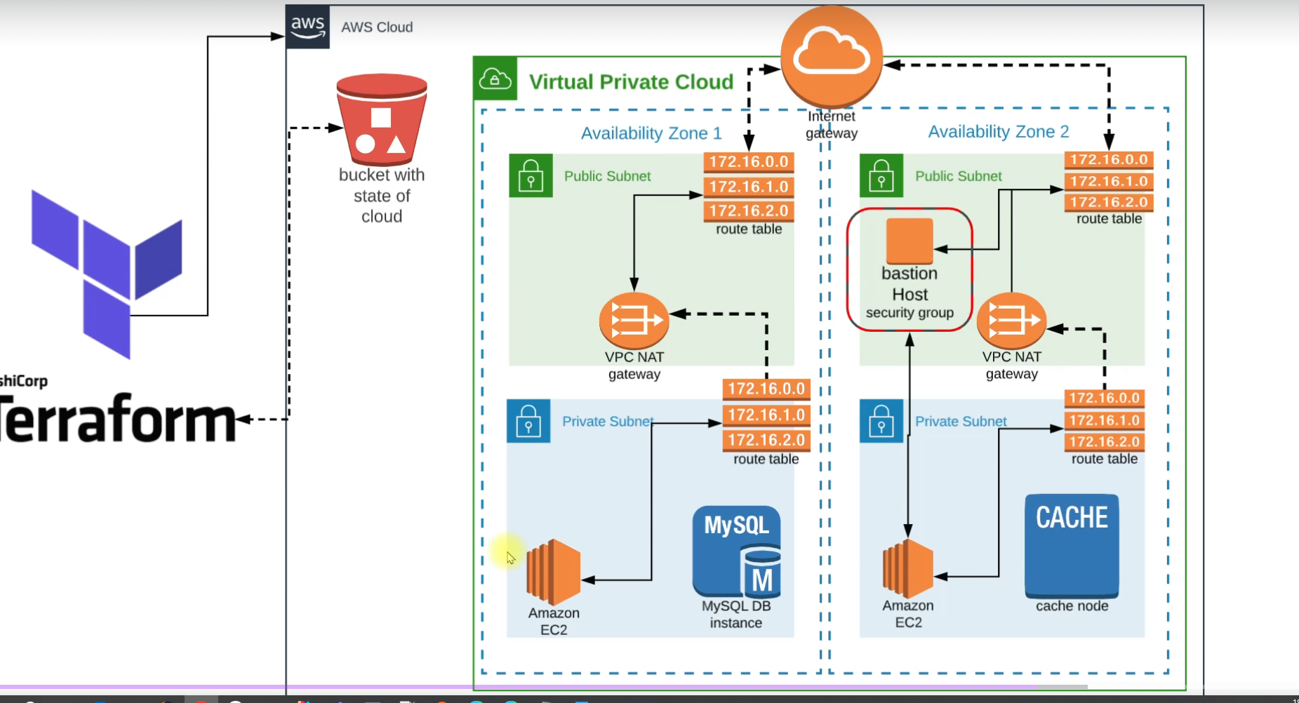

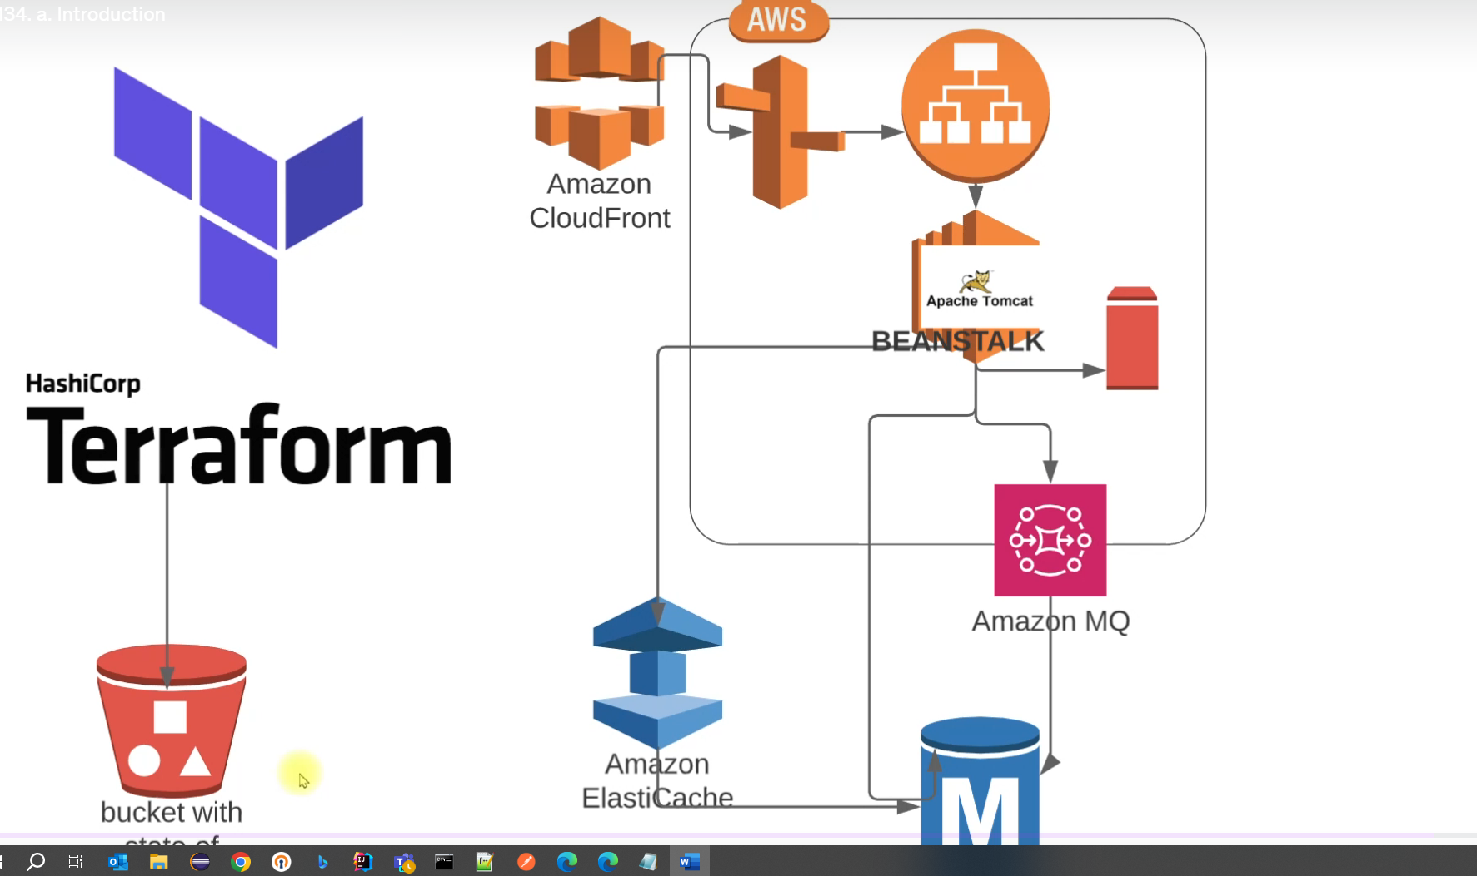

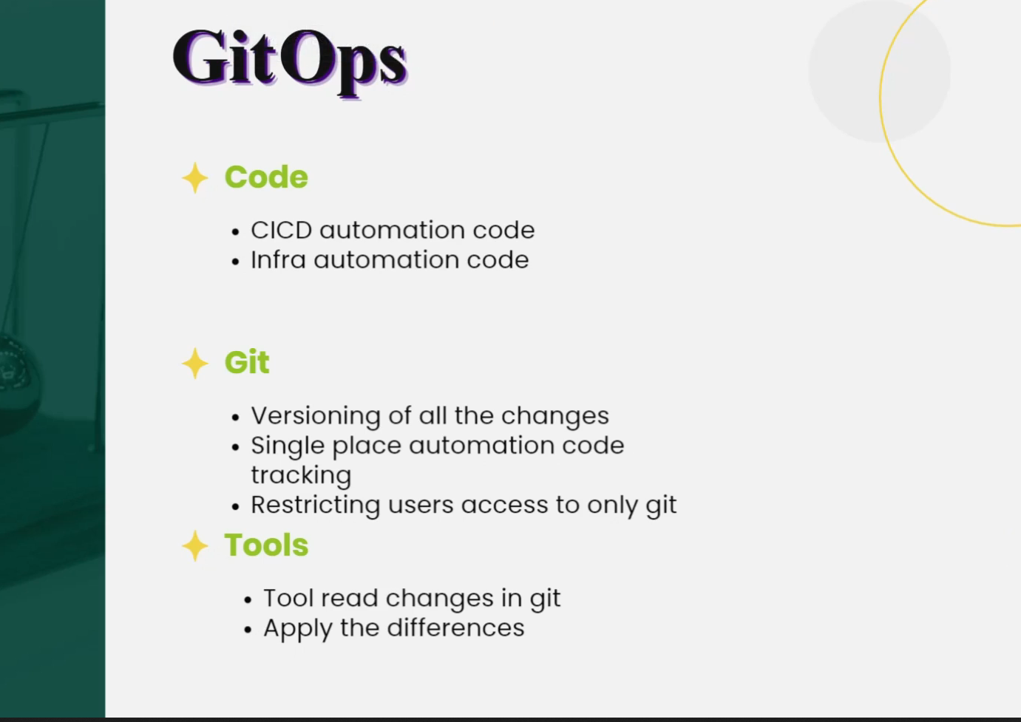

**Gitops:**   
With gitops you can restrict manual changes to infrastructure. Also restrict users to apply changes to infra code.

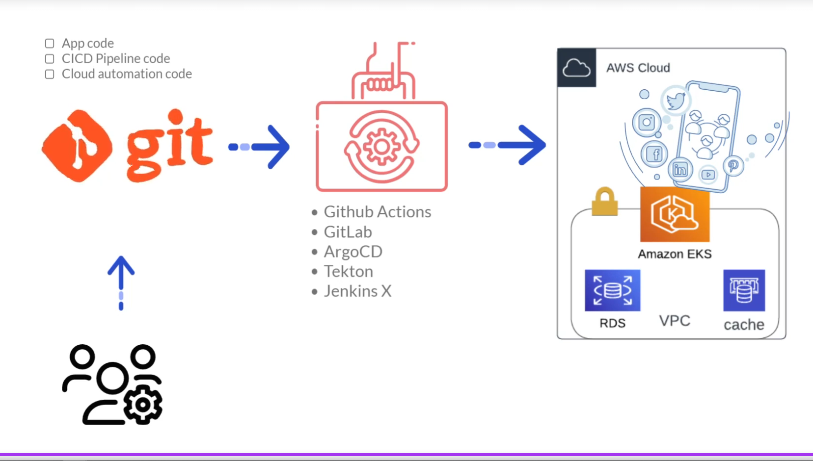

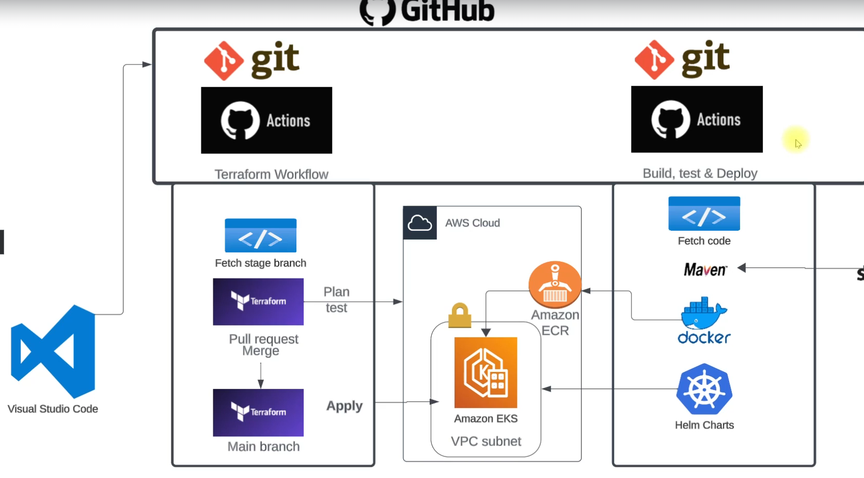

**20) Ansible**